**Python Shit**

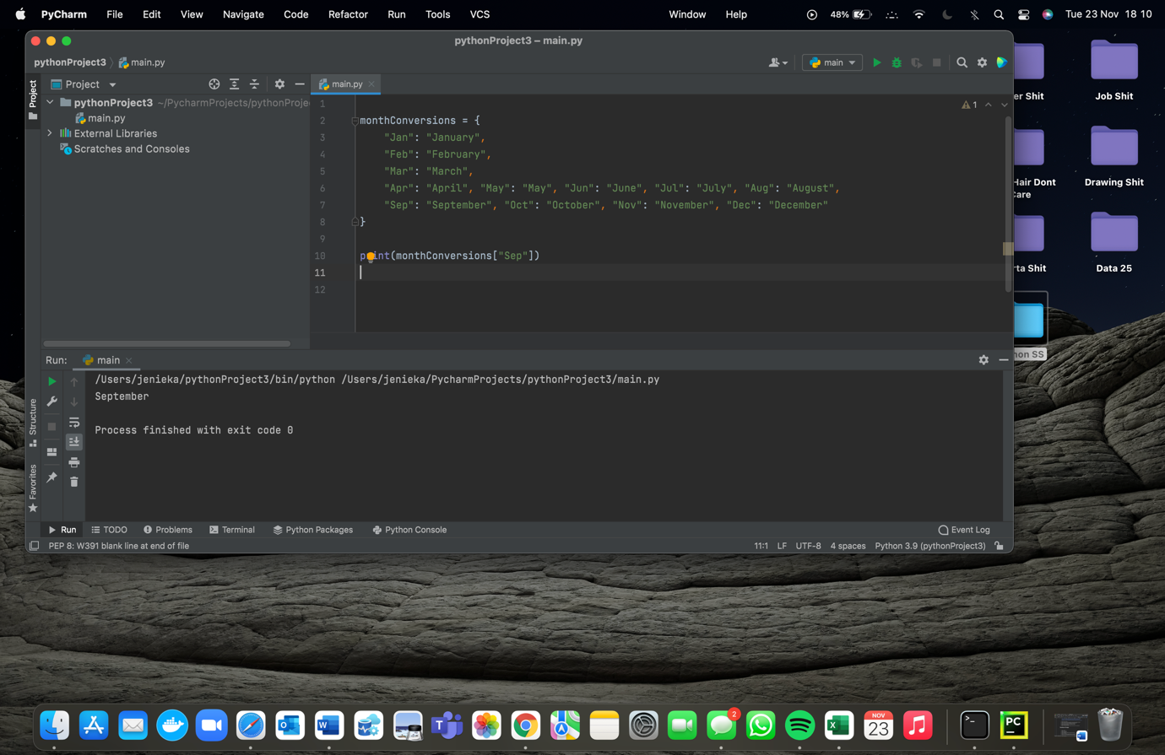

Am not entirely sure what is happening here. Maybe

Oh wait it’s Dictionary, so kind of like a shortcut so when you type in the first three letters of a month and print it, it gives you the full word of that month.

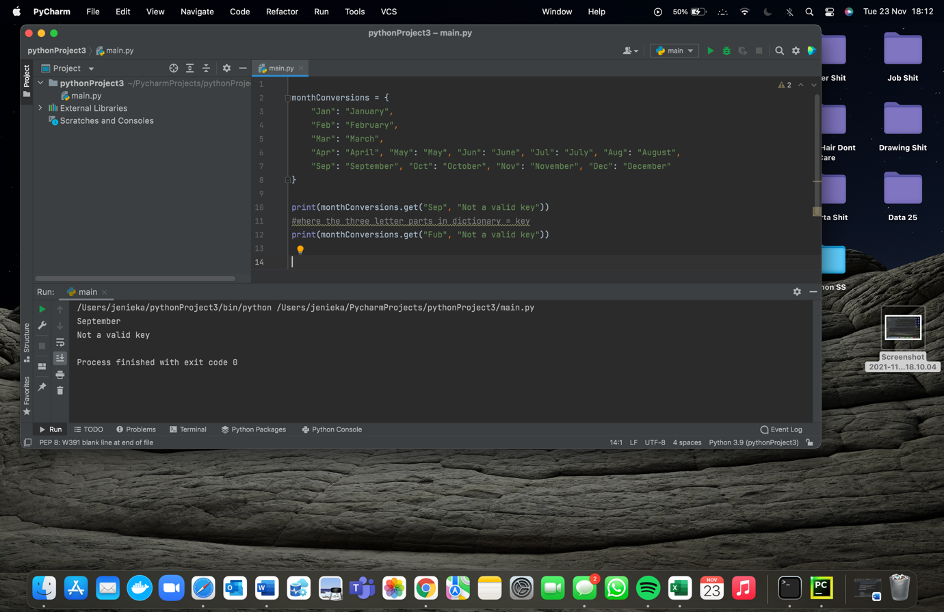

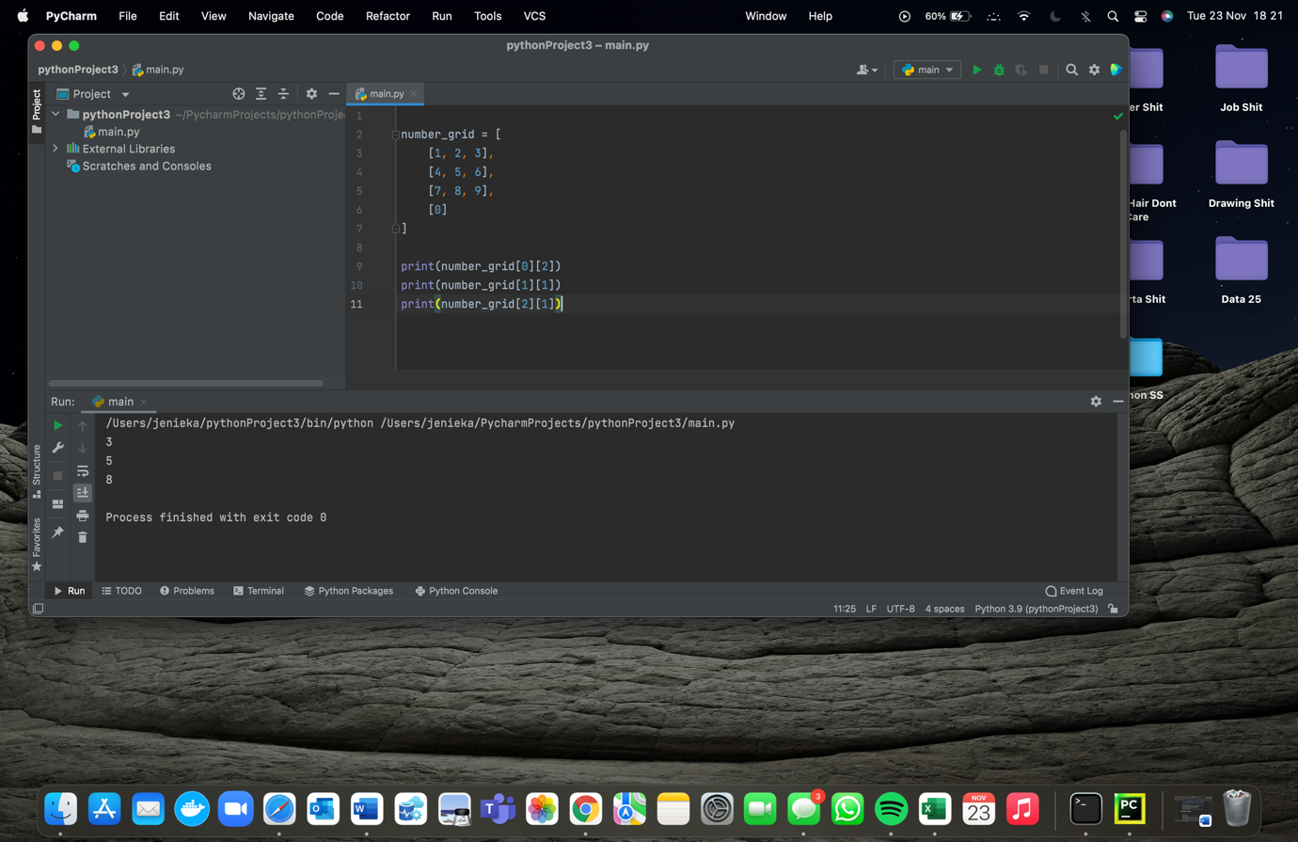Is just showing that if there’s no entry you can tell it to type something else, here being “not a valid entry”.

Idk what to call this but yeah it just does its thing. It’s showing how you choose a row and entry from an inputted number grid it will print what you asked.

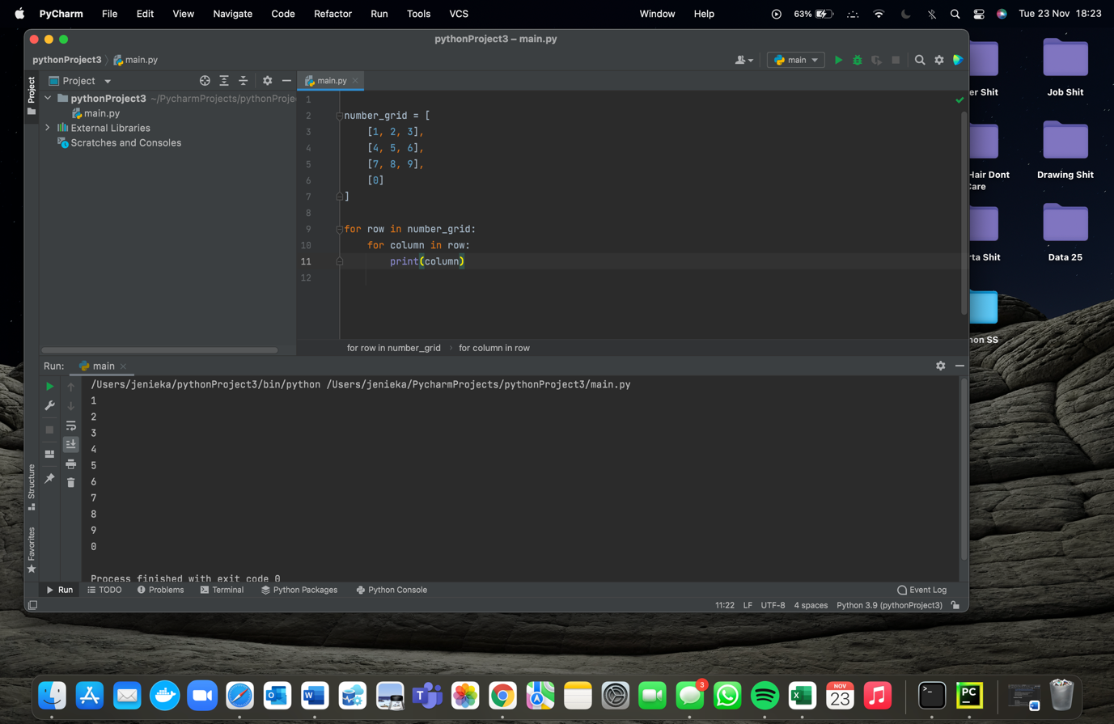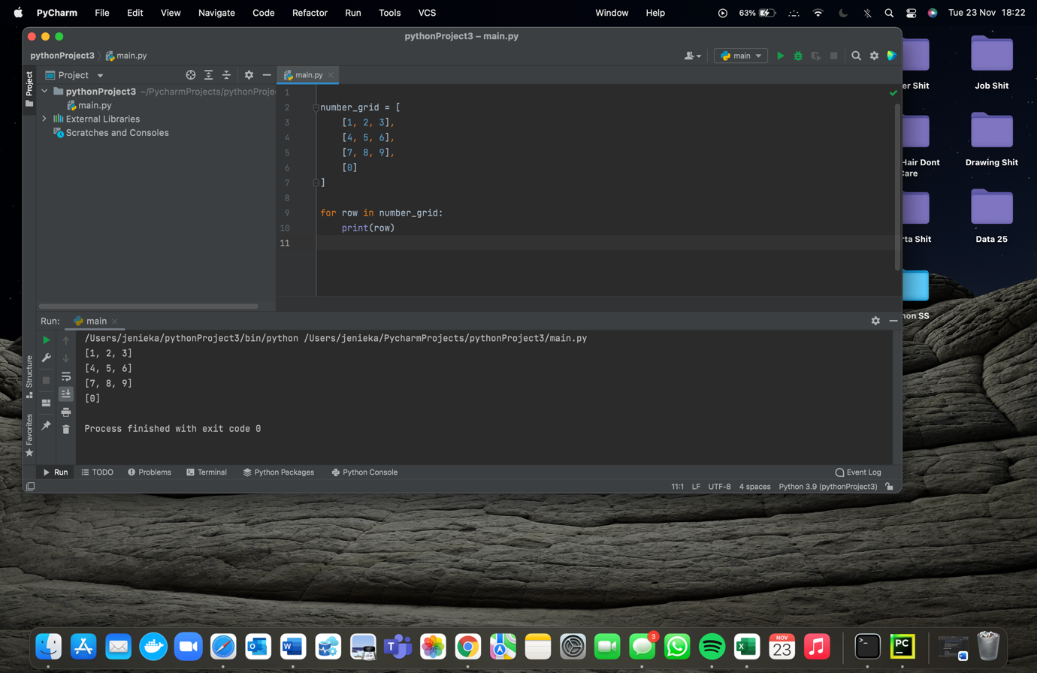This is just showing how to use a for loop to print out each row in the number grid.

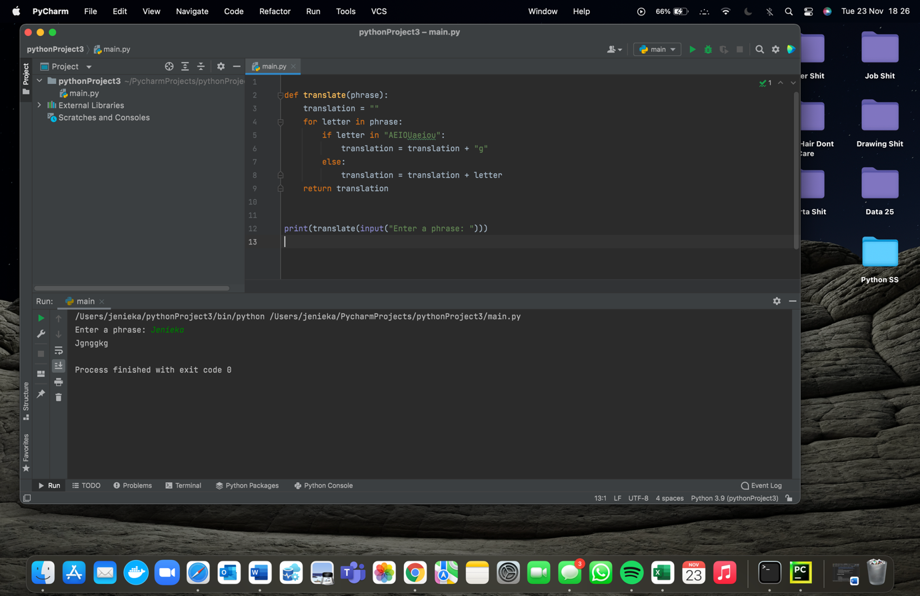Same as above just printing in a different format.

This just shows how to make a function which is a translator.

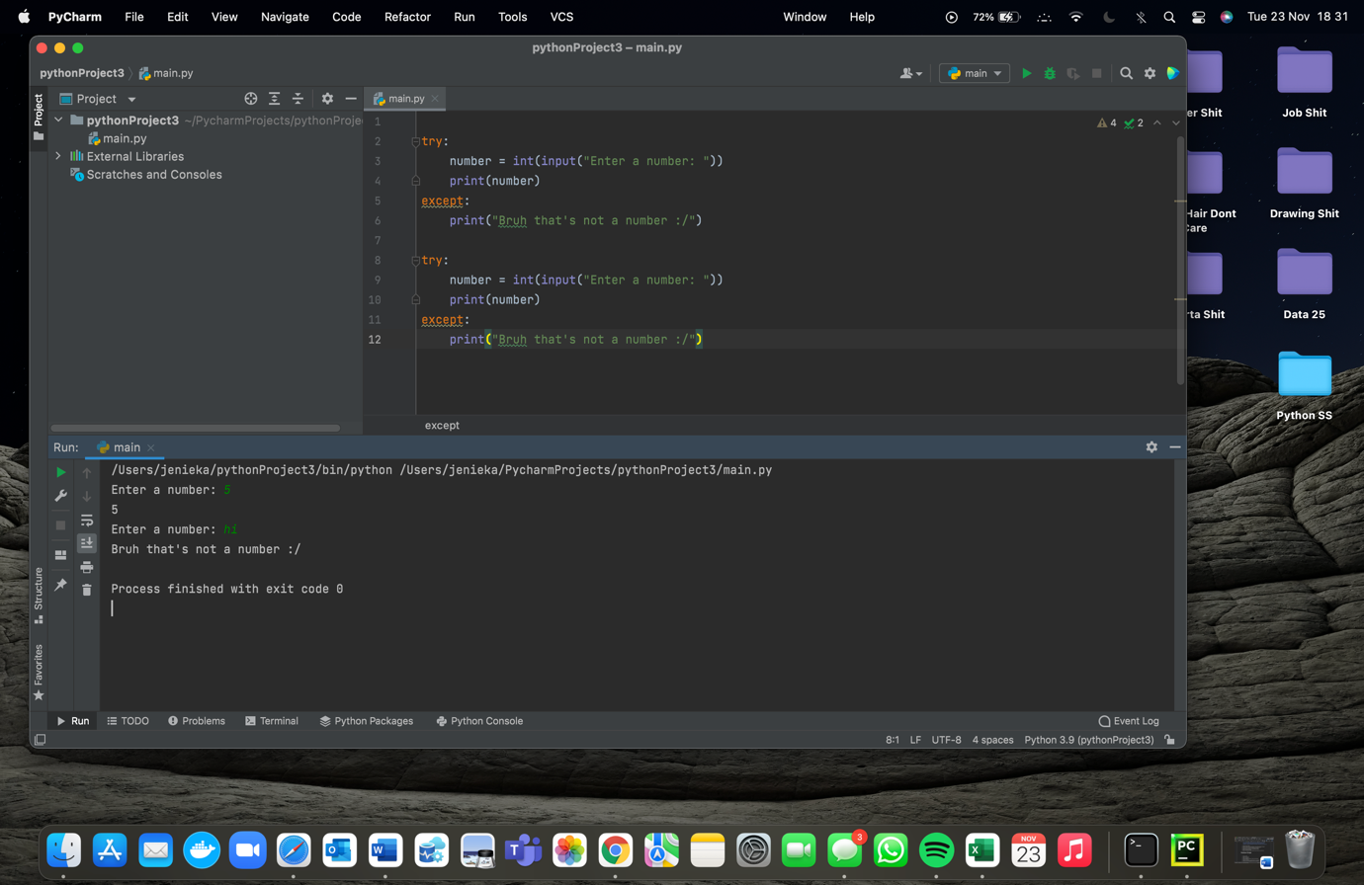

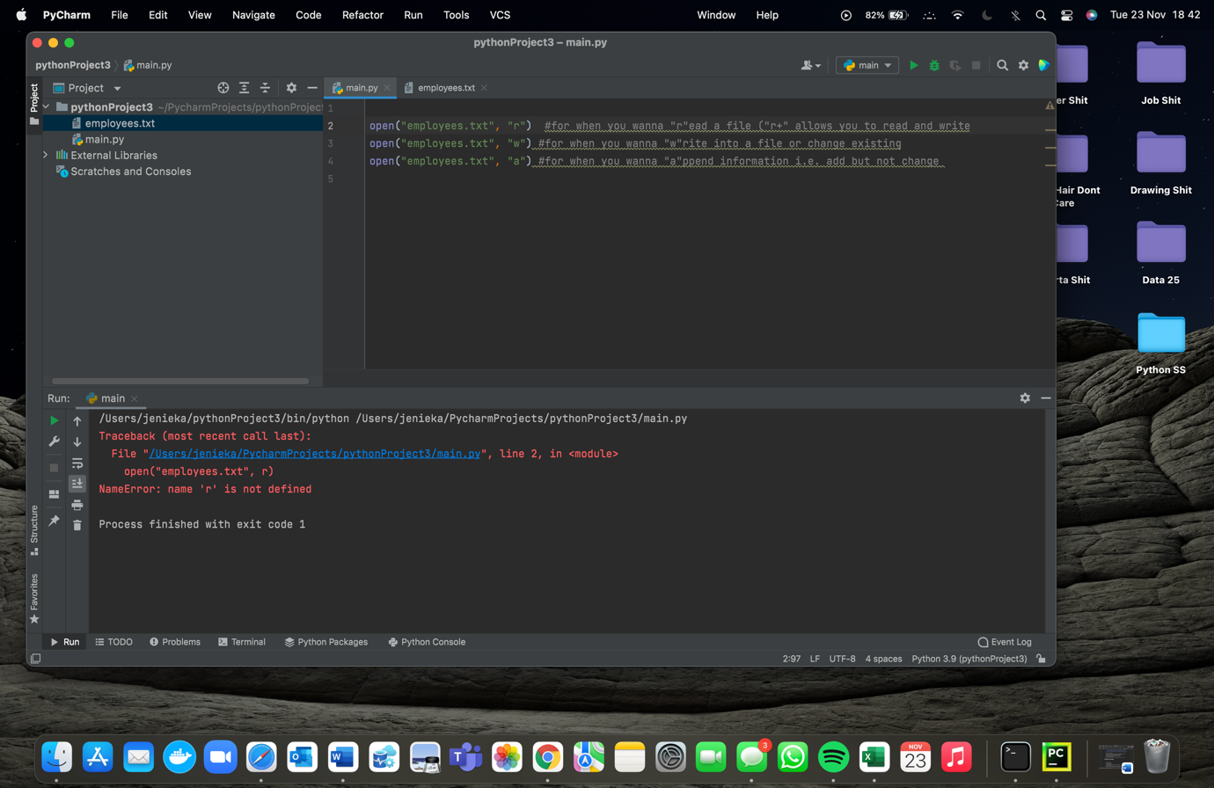An example of try and except statements.

I mean read the comments and ignore the errors- just showing how you would “open” another file to either read, write or amend.

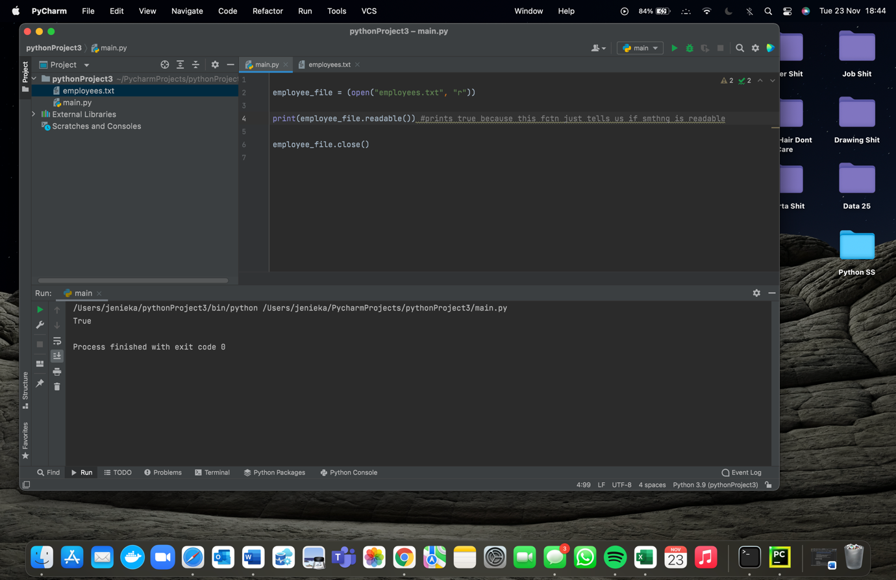

Shows how to ask if a file is readable.

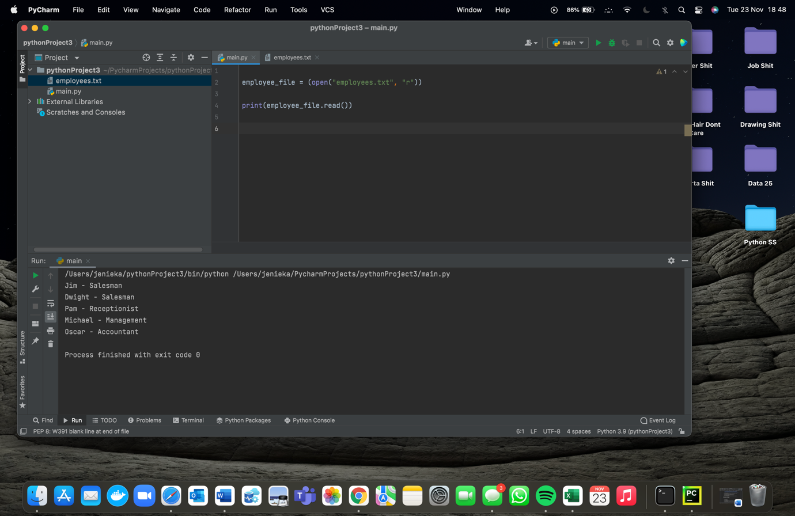

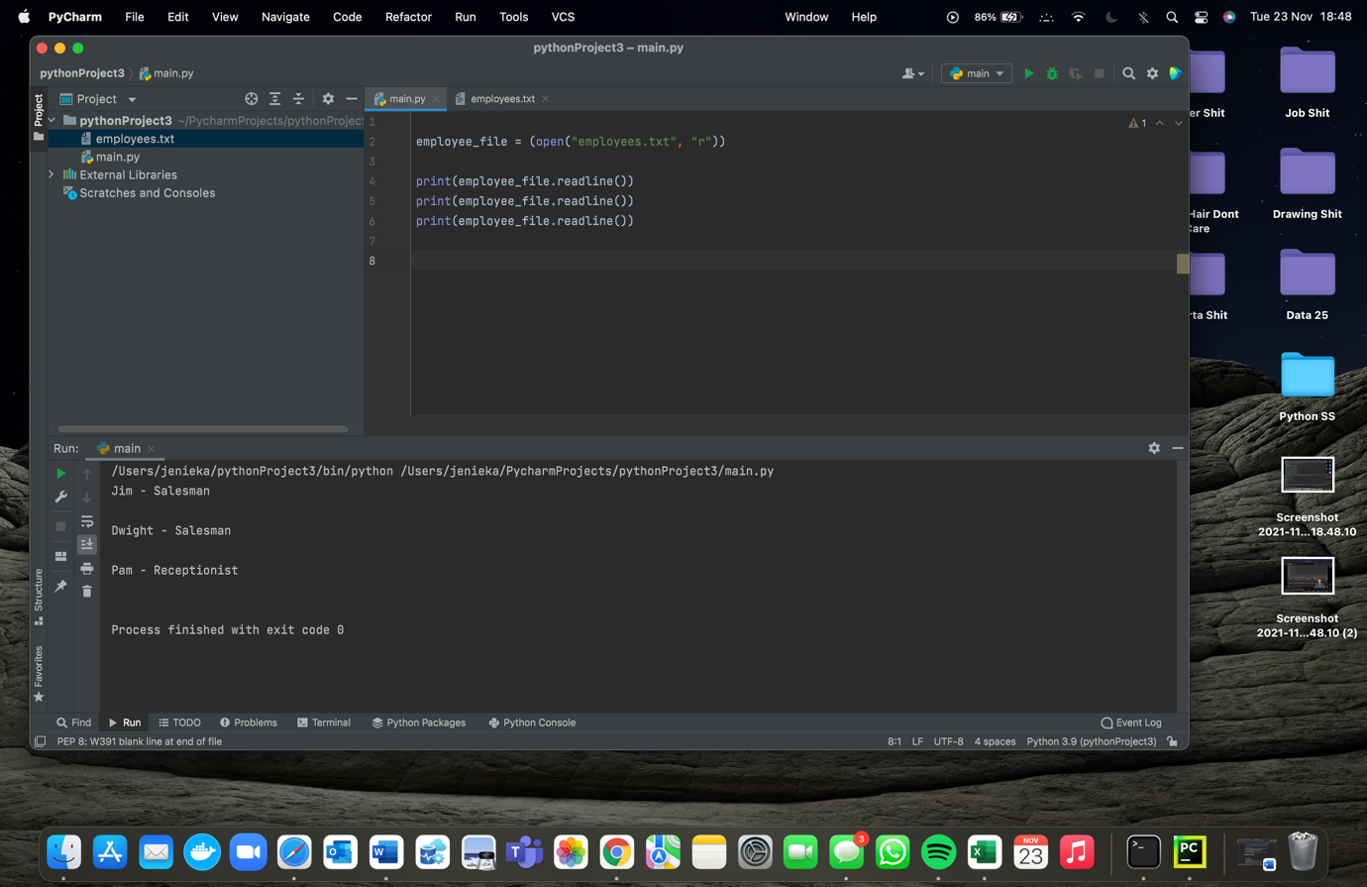Shows how to read information from another file.

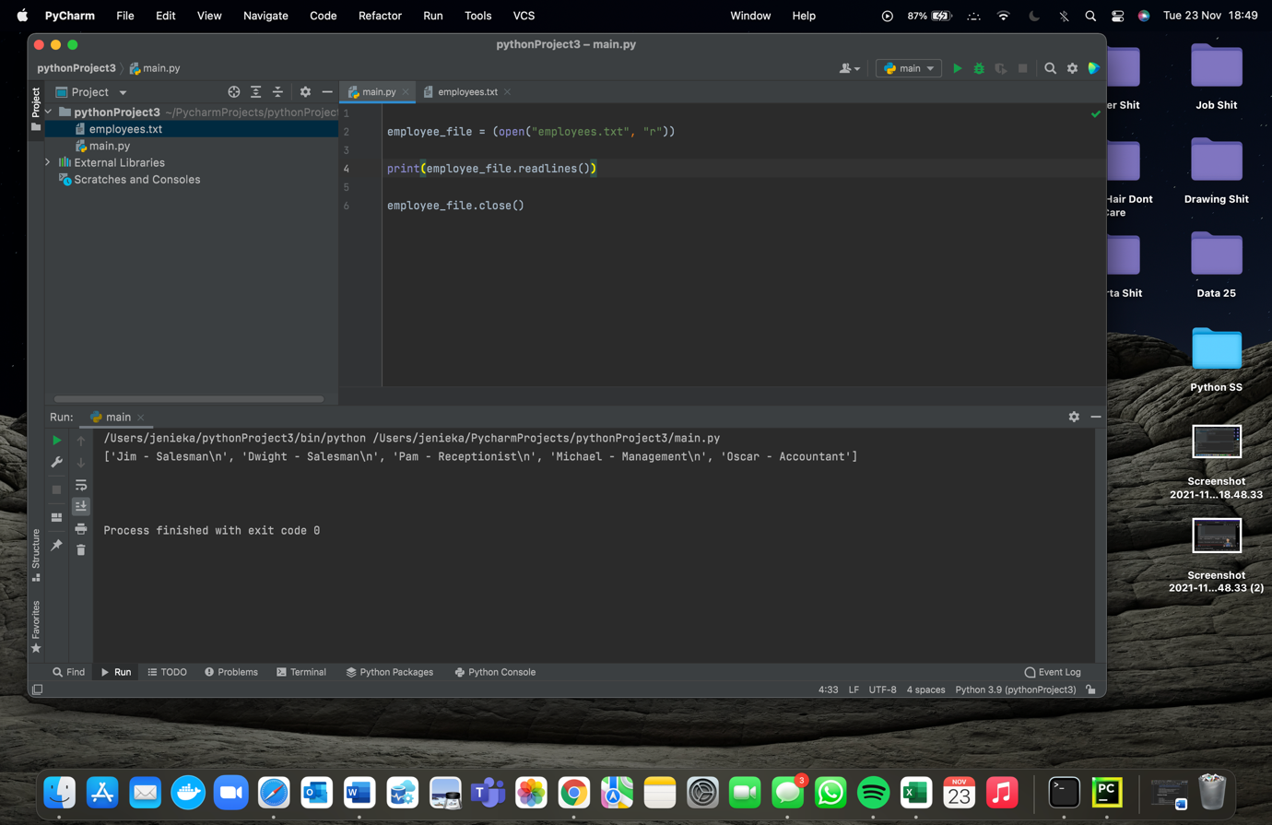Shows you how to read specific lines in another file but will kind of sort

them one by one.

Shows you how to

read all the lines at

once from a specific file.

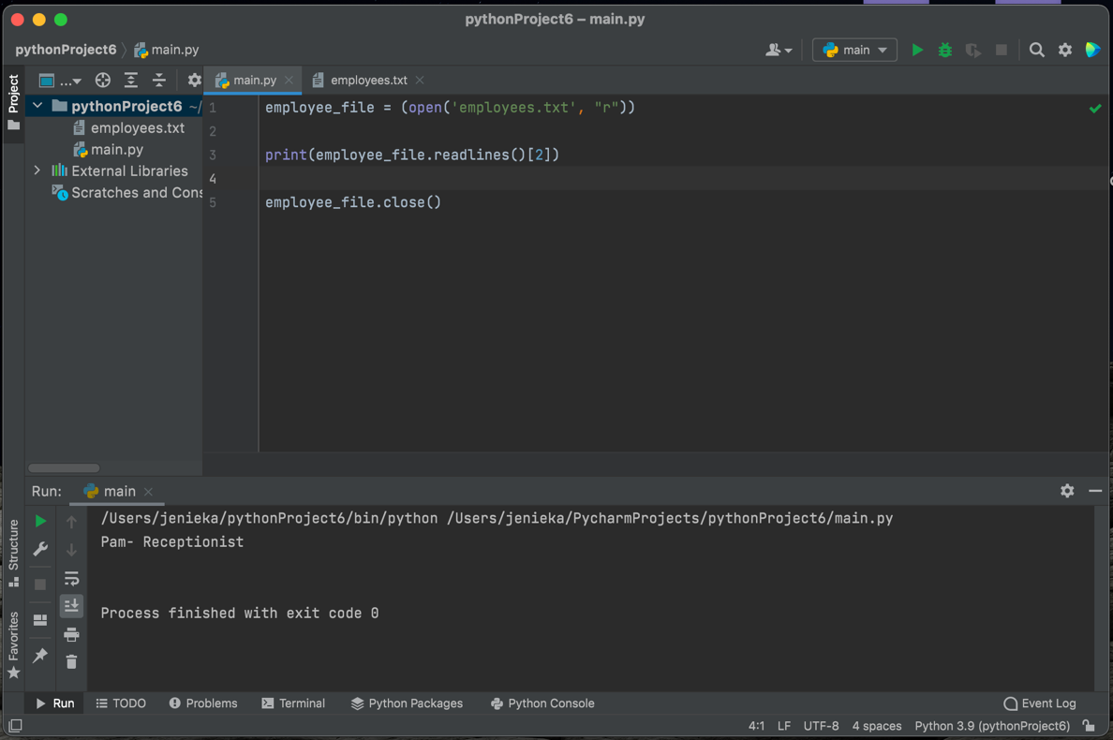

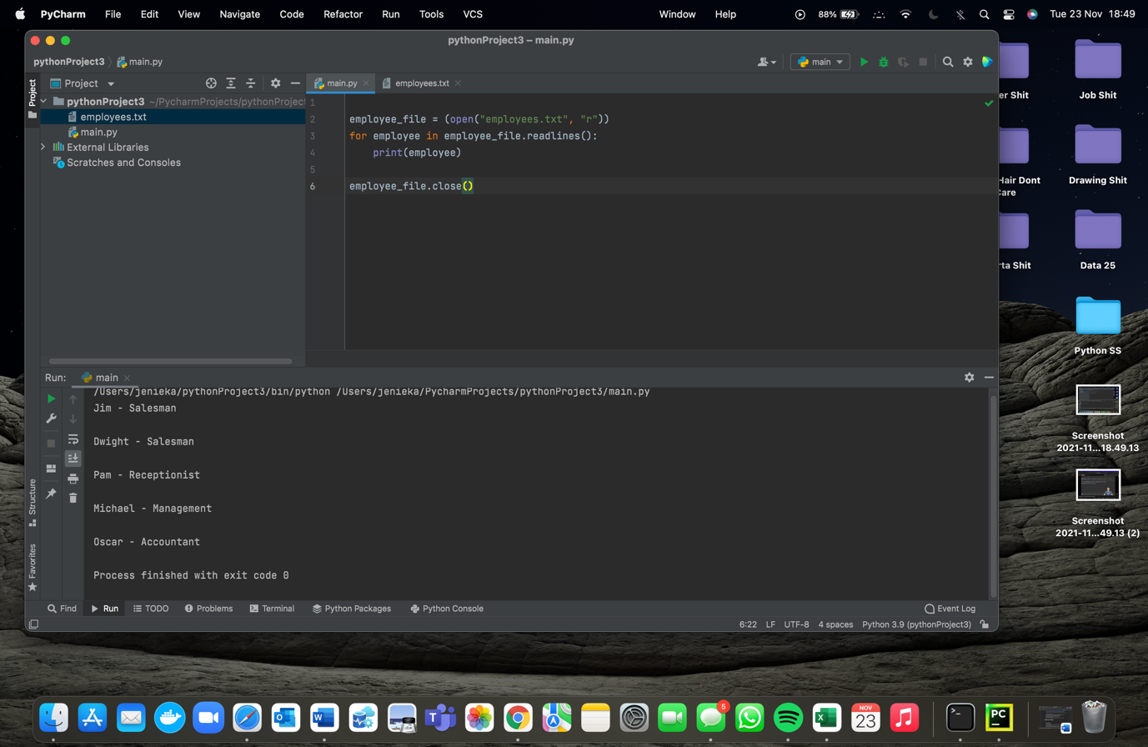 Shows how to access specific files, obvs with lines starting from 0.

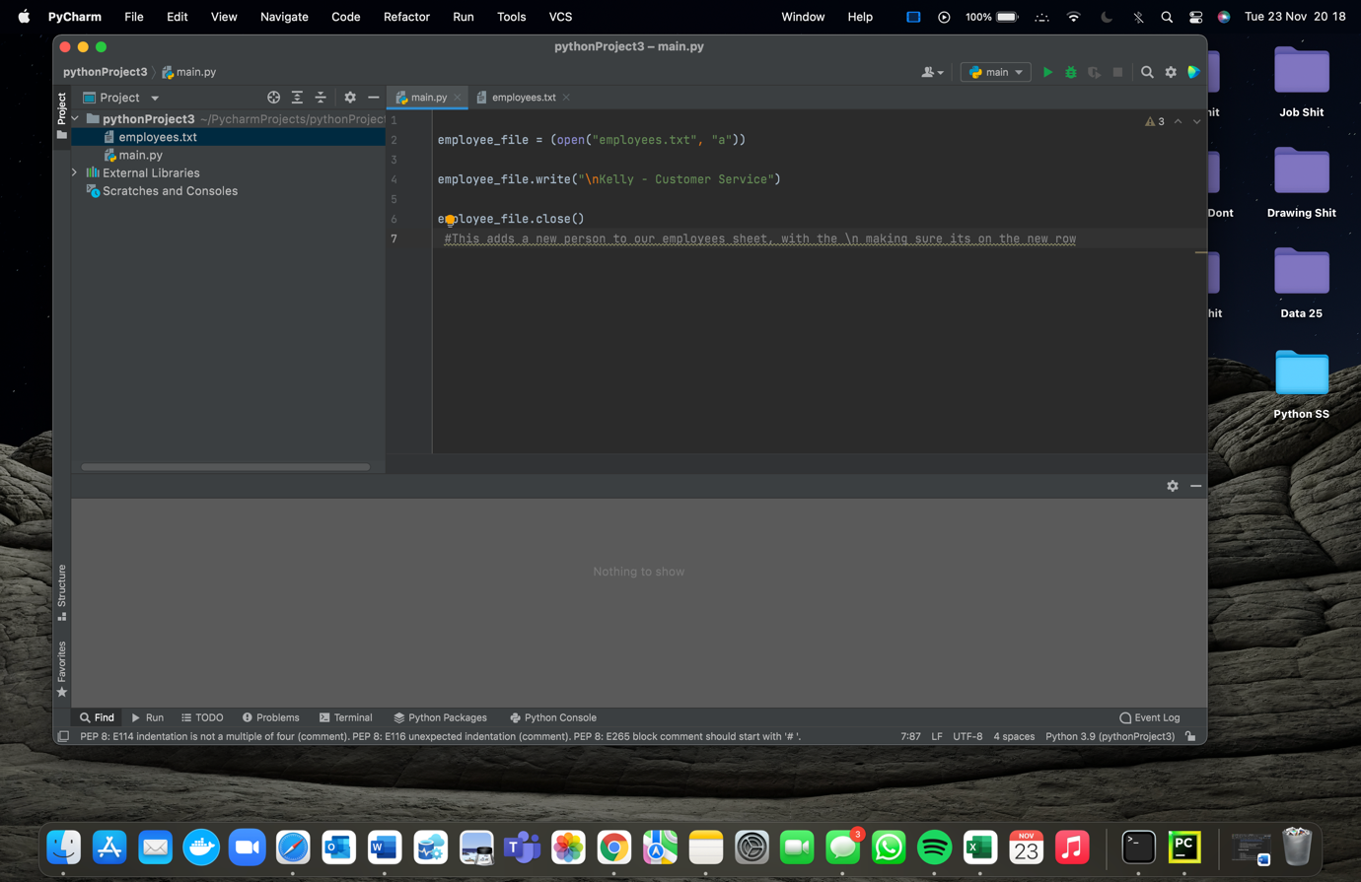This will just print every line in t’other file using a for loop.

This shows how to add to the other file.

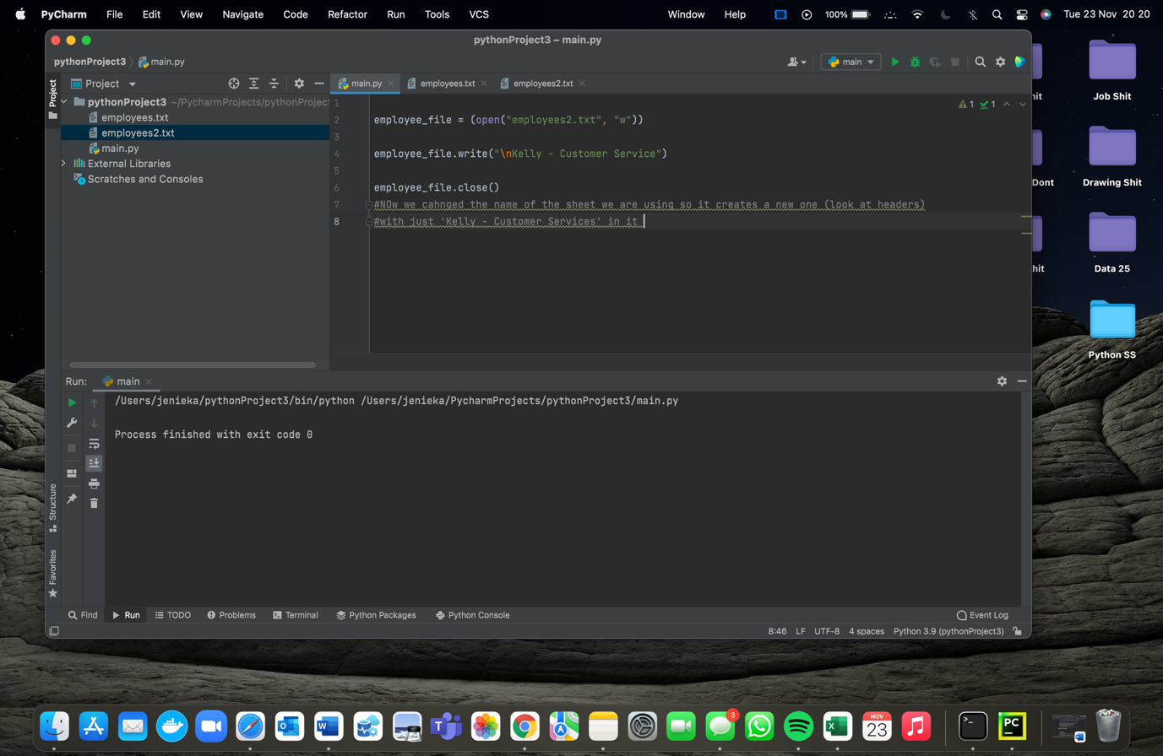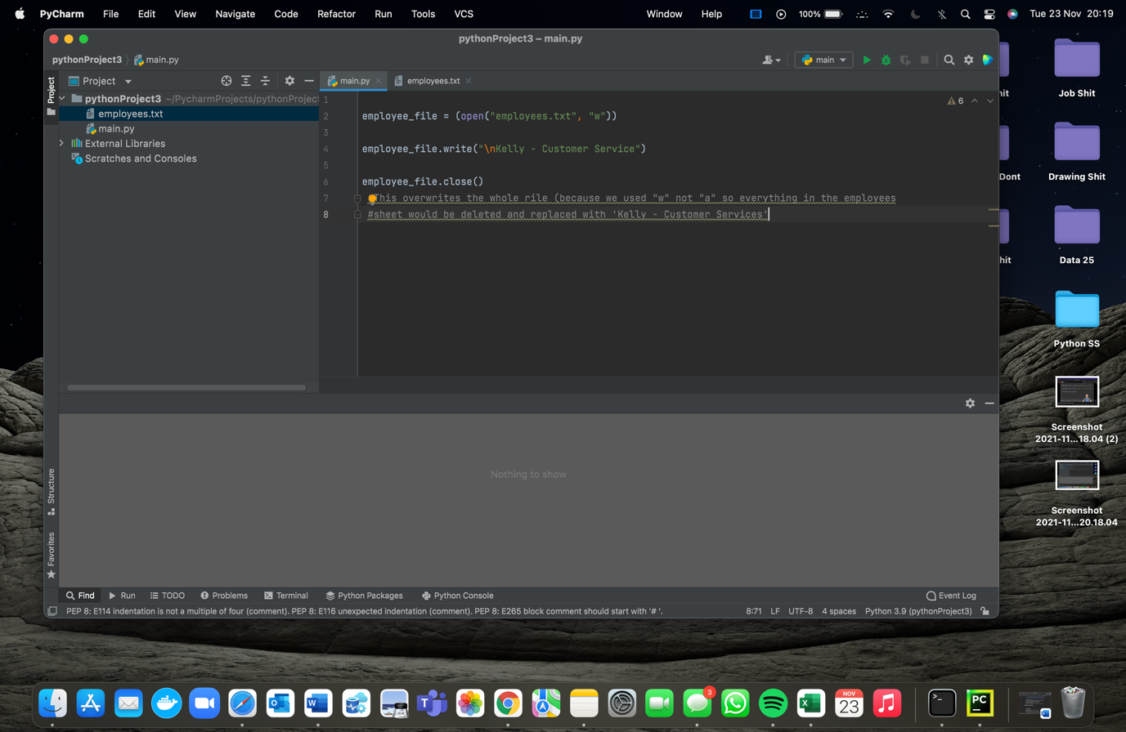This will overwrite the whole file so you remove everything and add summat else.

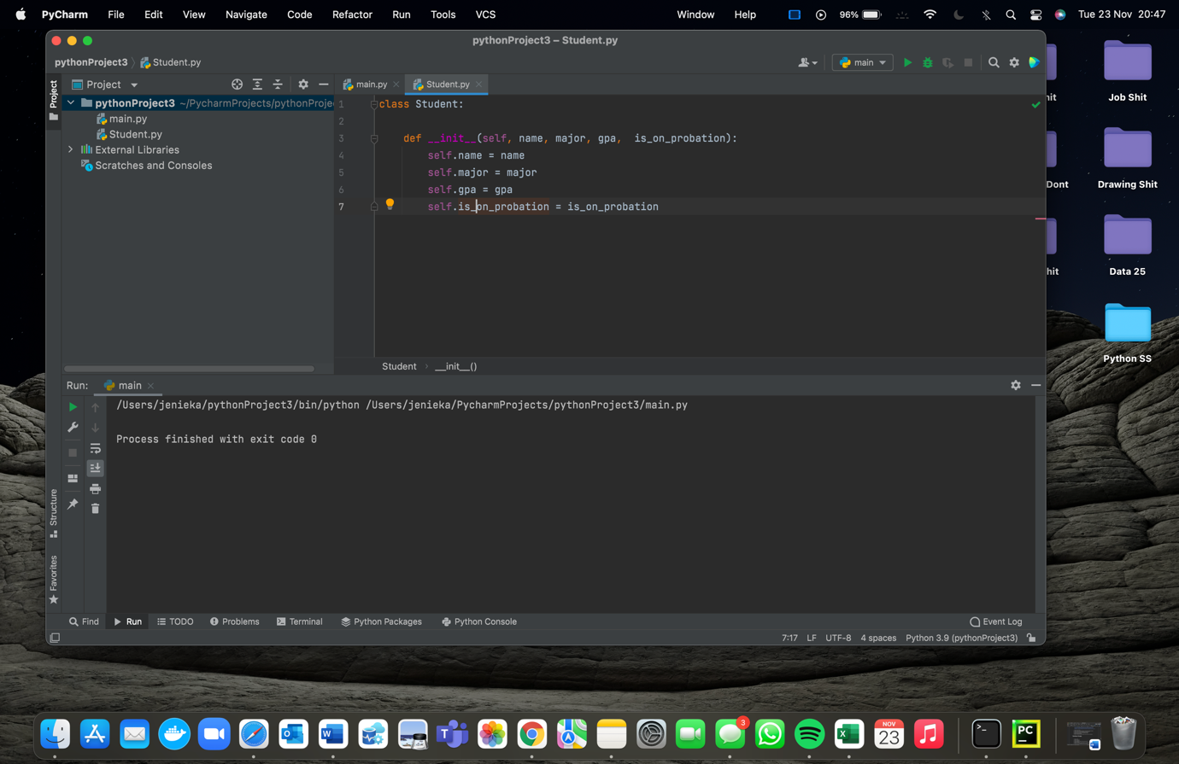Just read the effing comments.

This is just showing how to write a basic class. The next ss’s show how you use the class to print things from it.

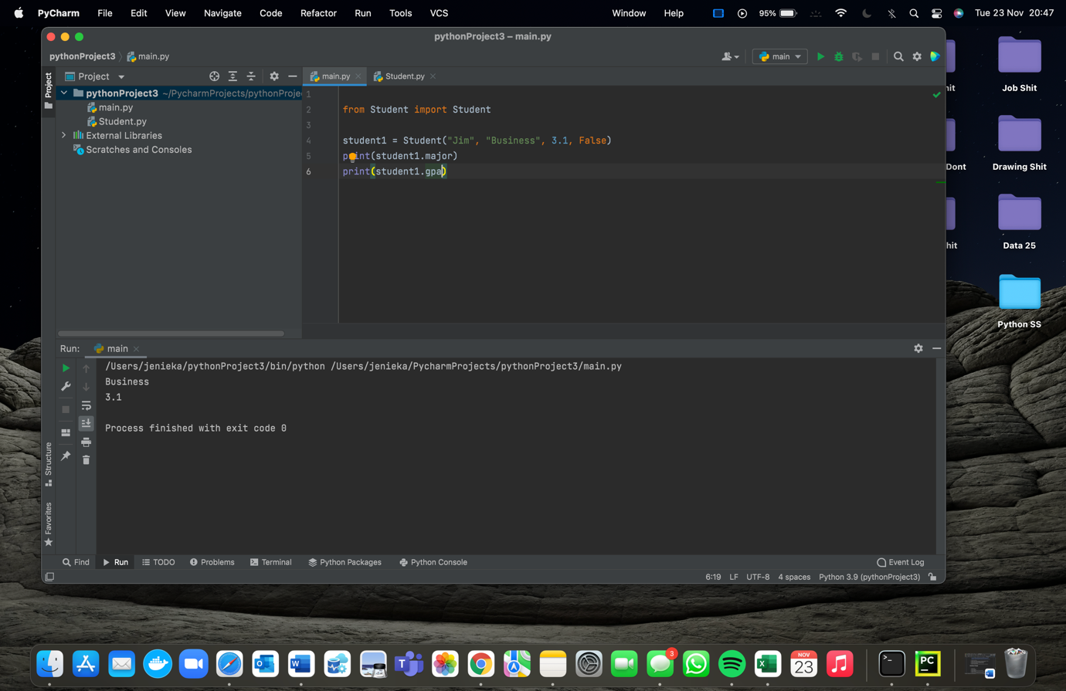

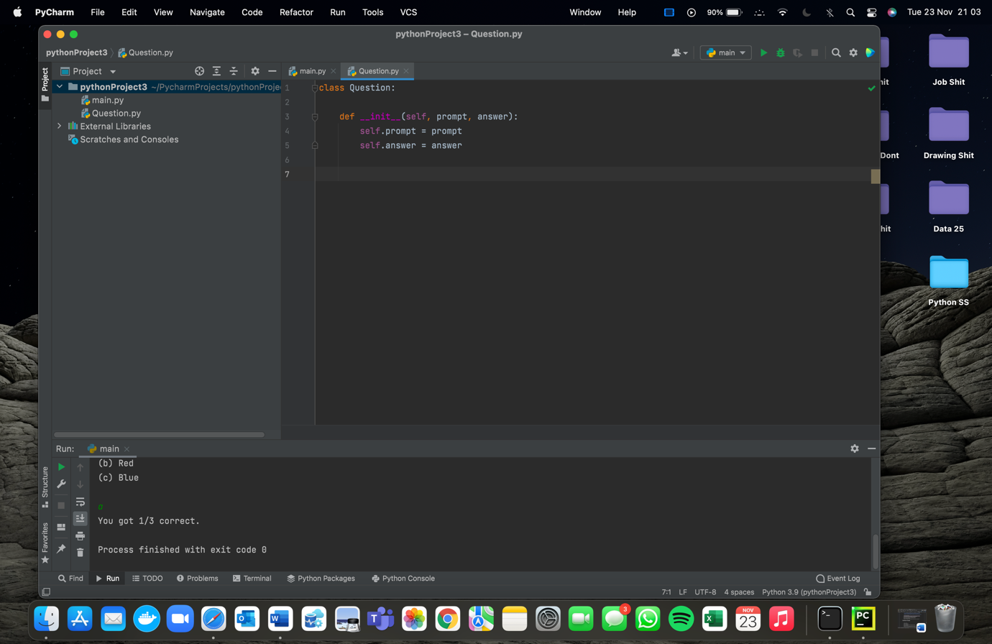Shows how to call things from a class.

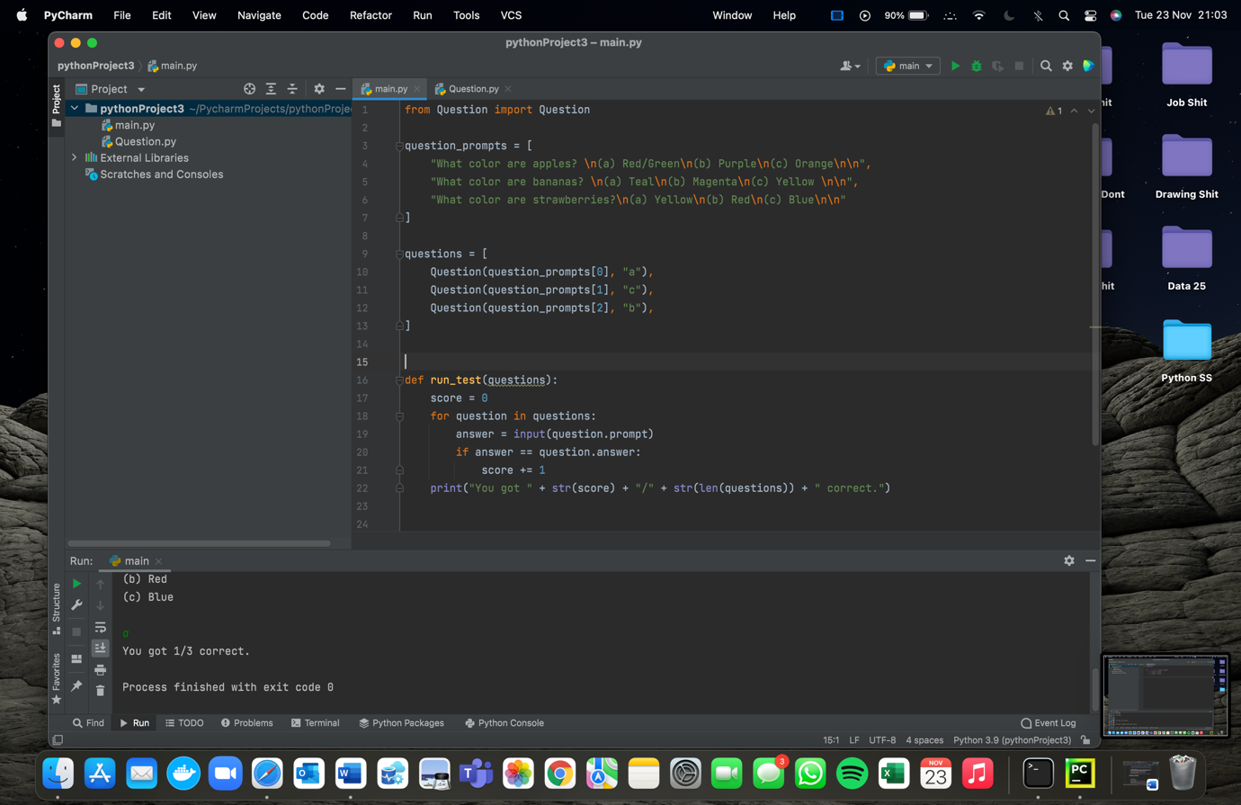This is a new class. The following ss’s show how to use it, again.

This is a way in which you can use the Questions class.

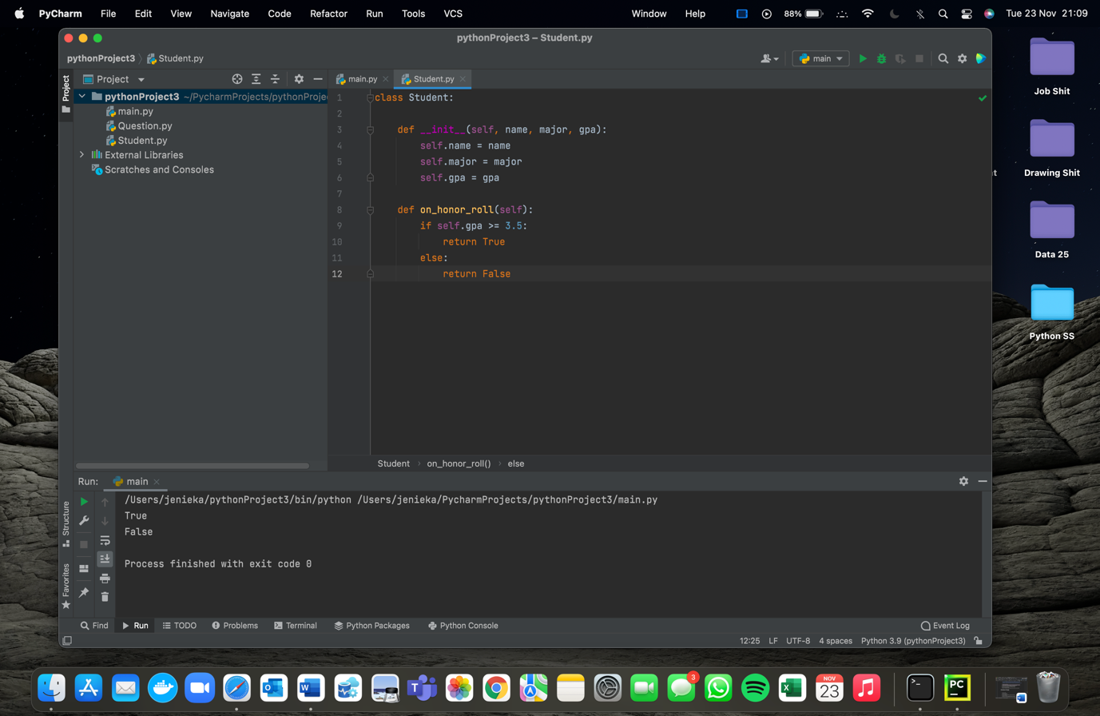

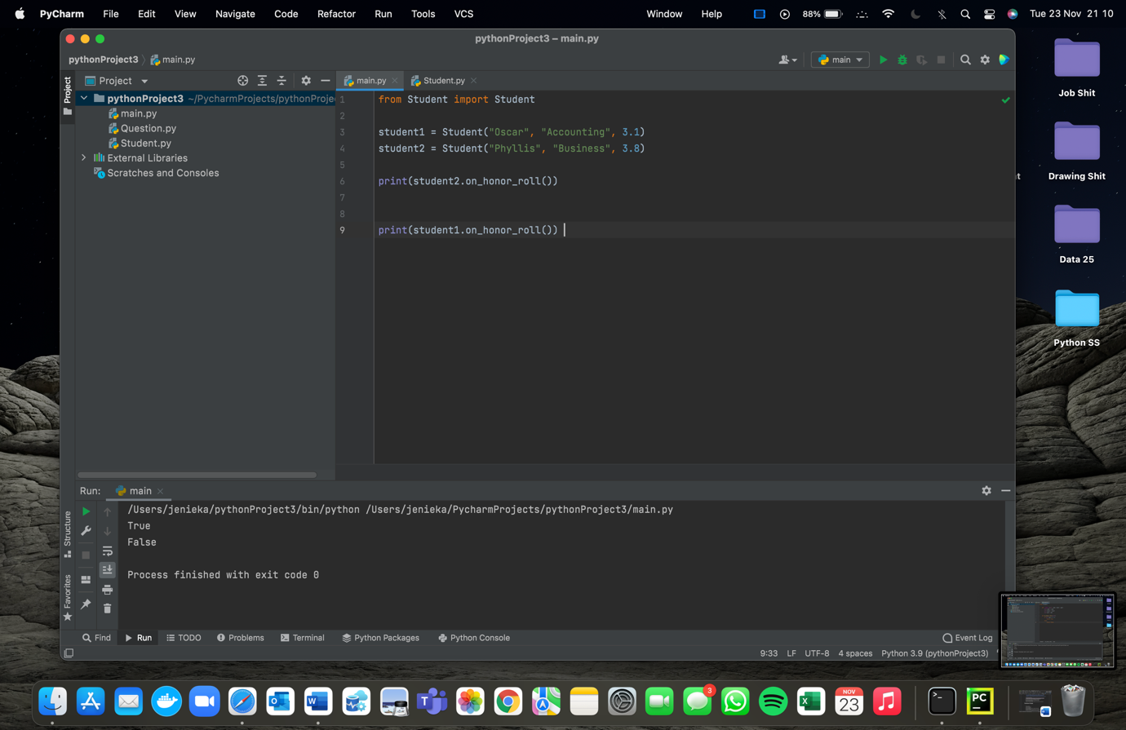This is a different class – the student class.

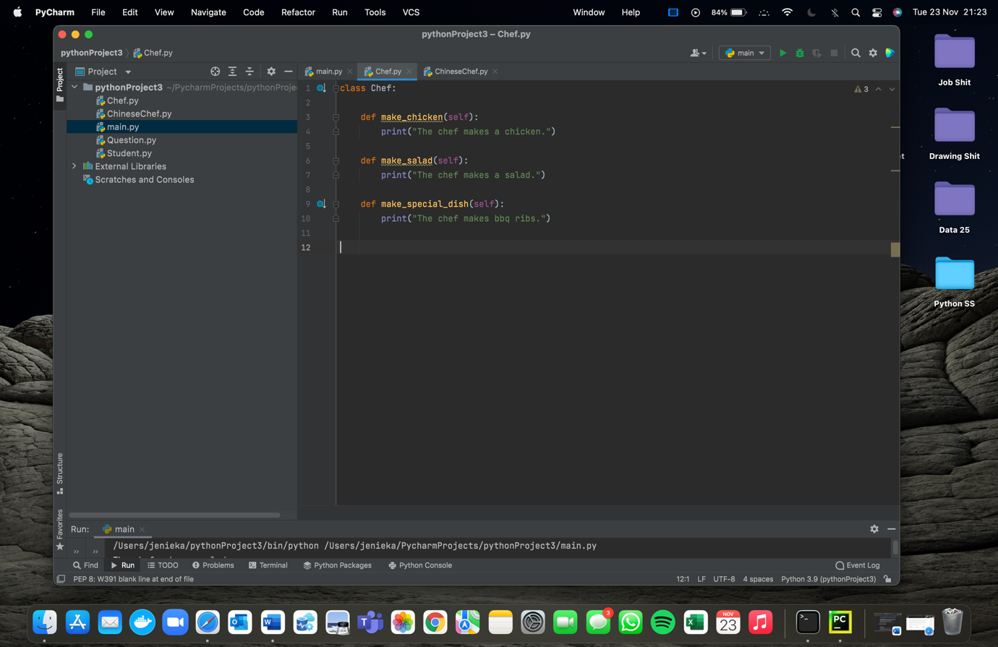This is a way to use the student class.

This is an example where there are two classes with the second class on the following ss.

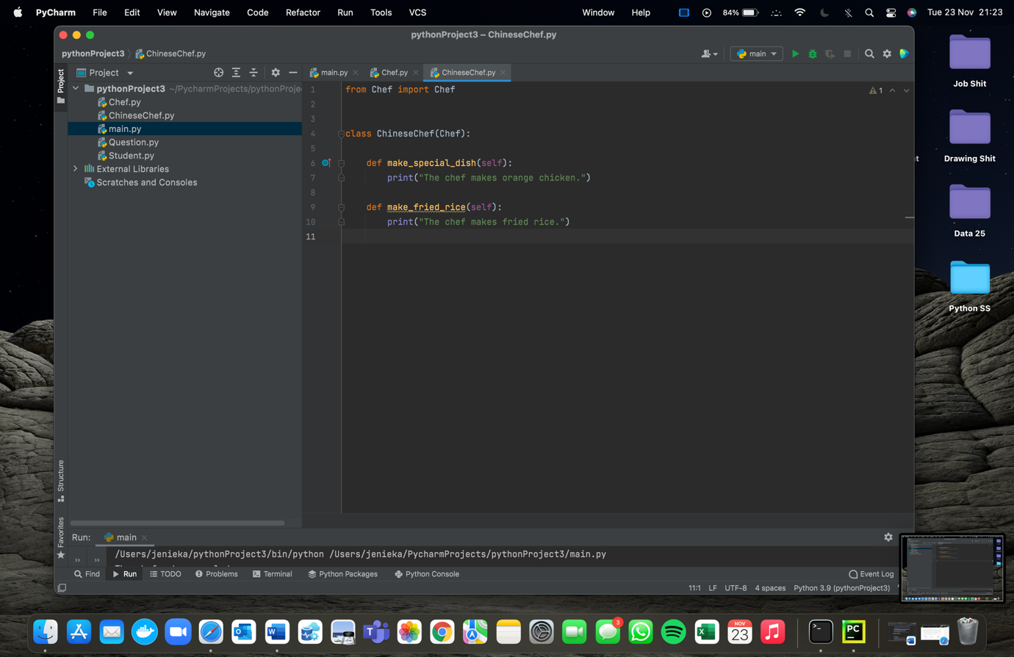

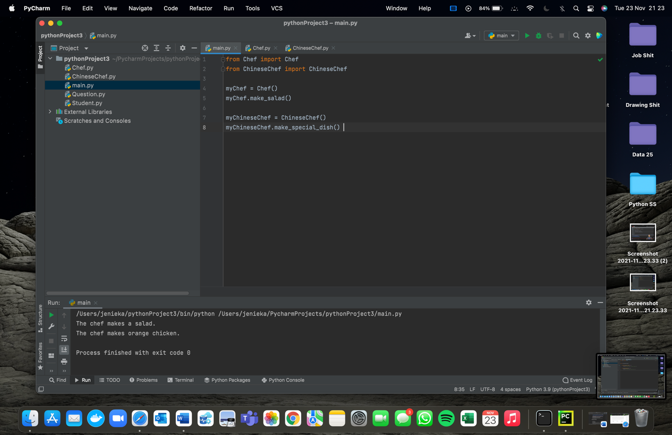This is the second class and the following ss shows how to use both classes.

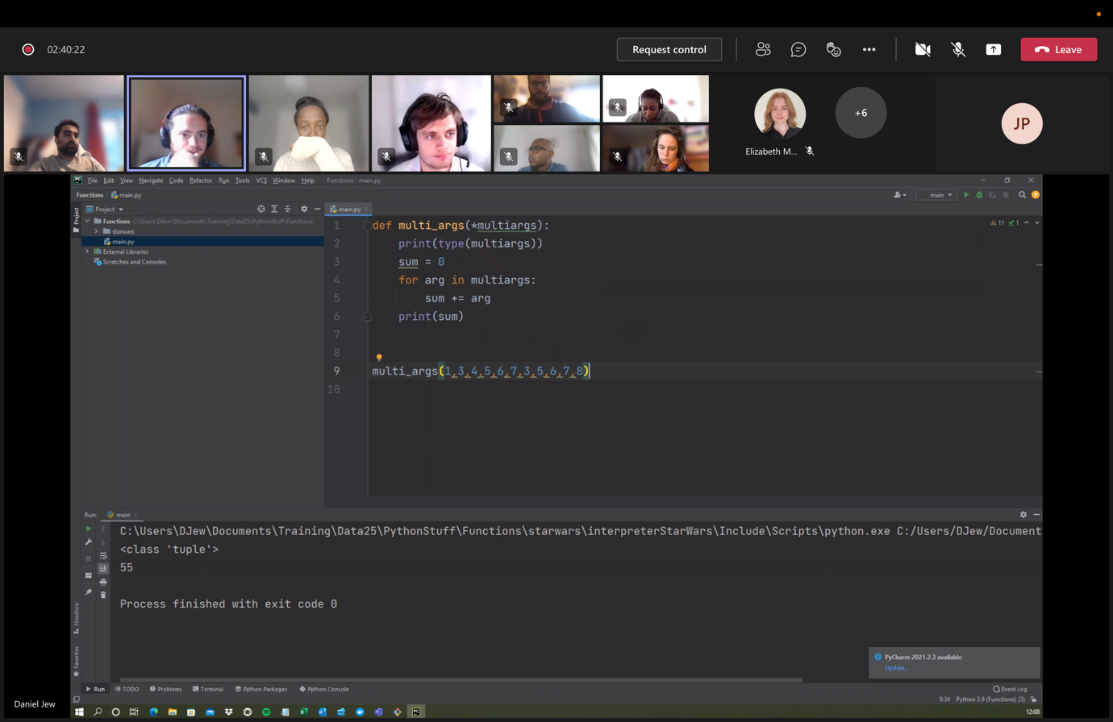 Yeah just look man.

This is how to use multiargs.

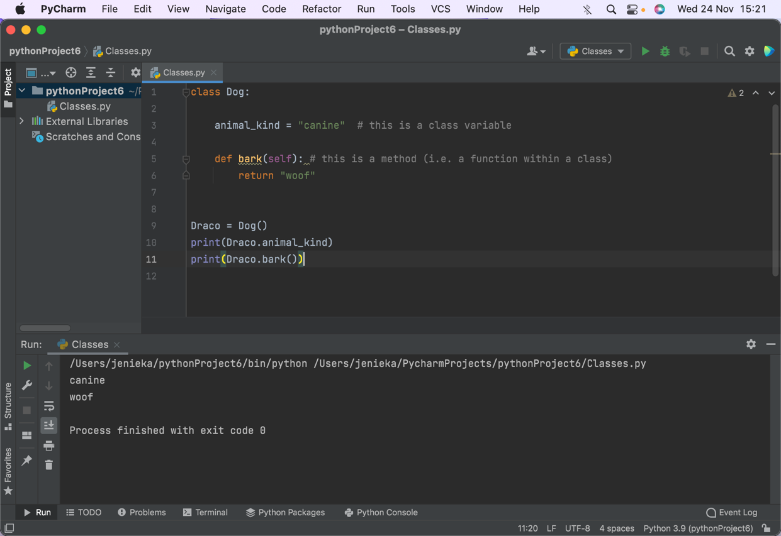

Danny did the following on the call on the 24th/ 25th (from car class onwards) Nov.

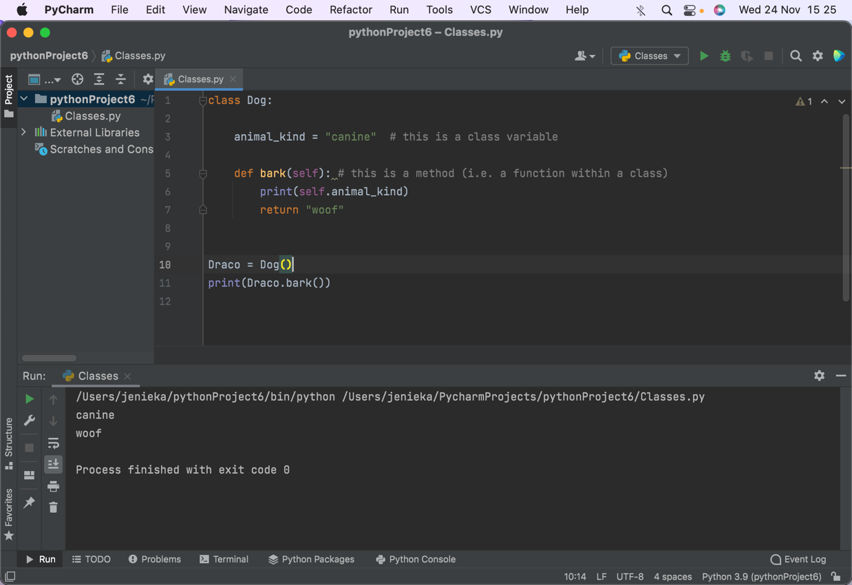

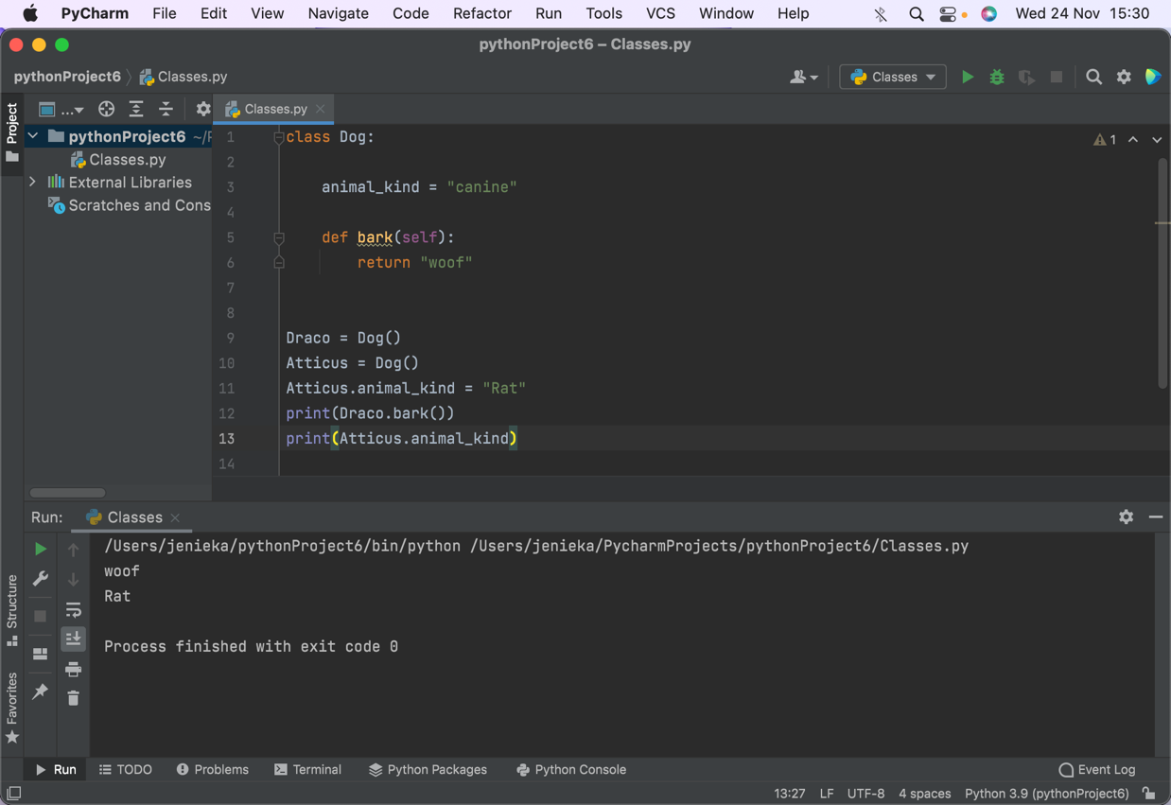

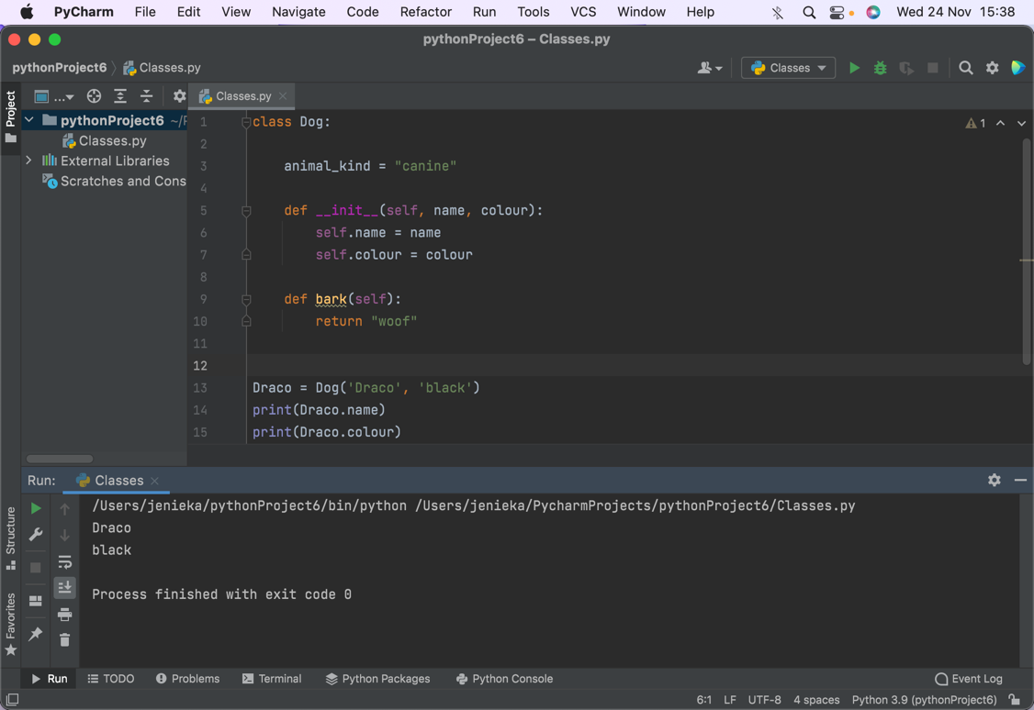

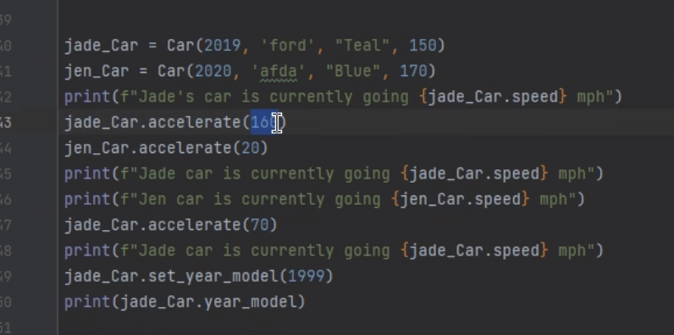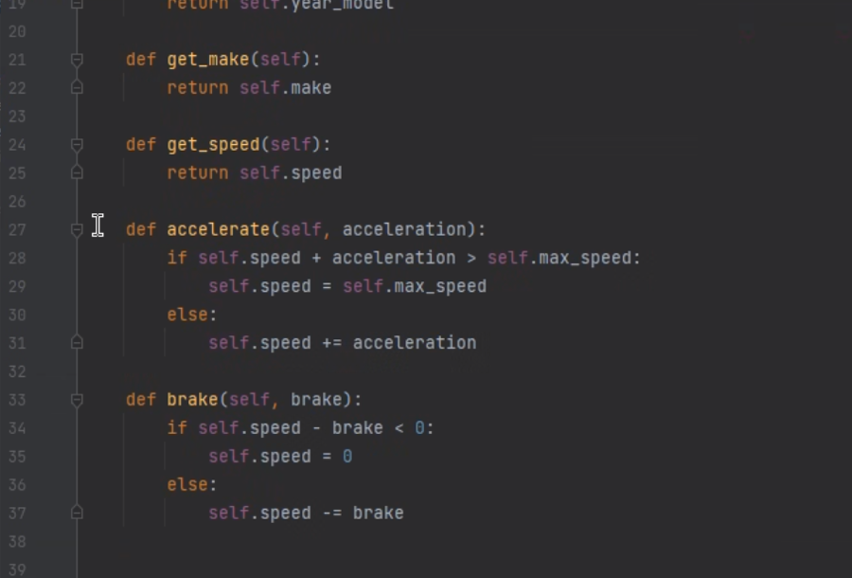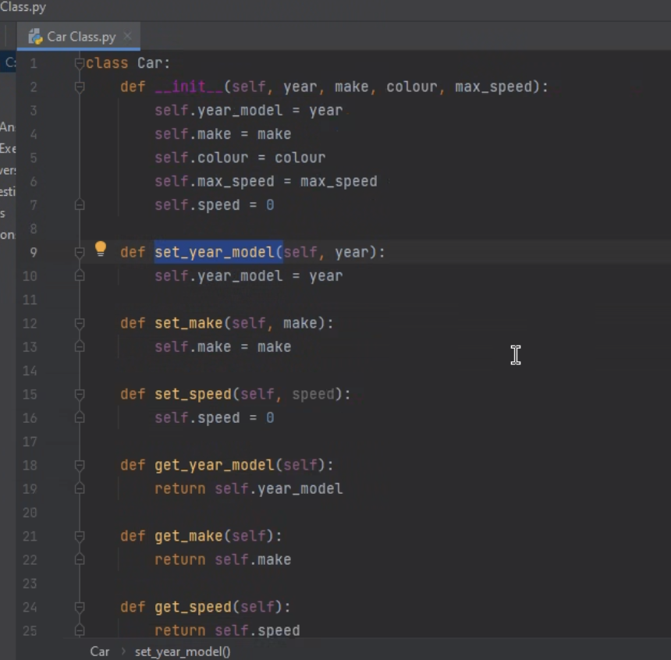 This next bit is a bigger example of a class:

The below is how to call the things in the class.

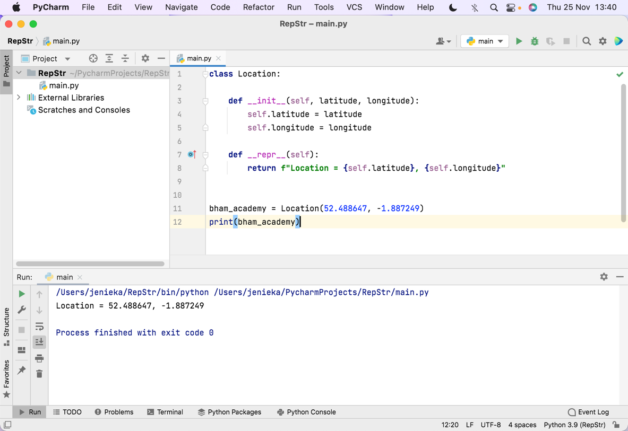

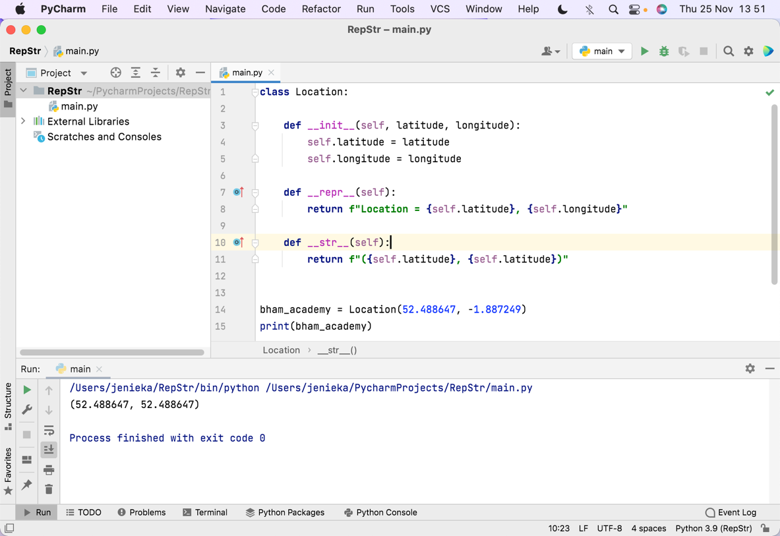Just another example of a class …

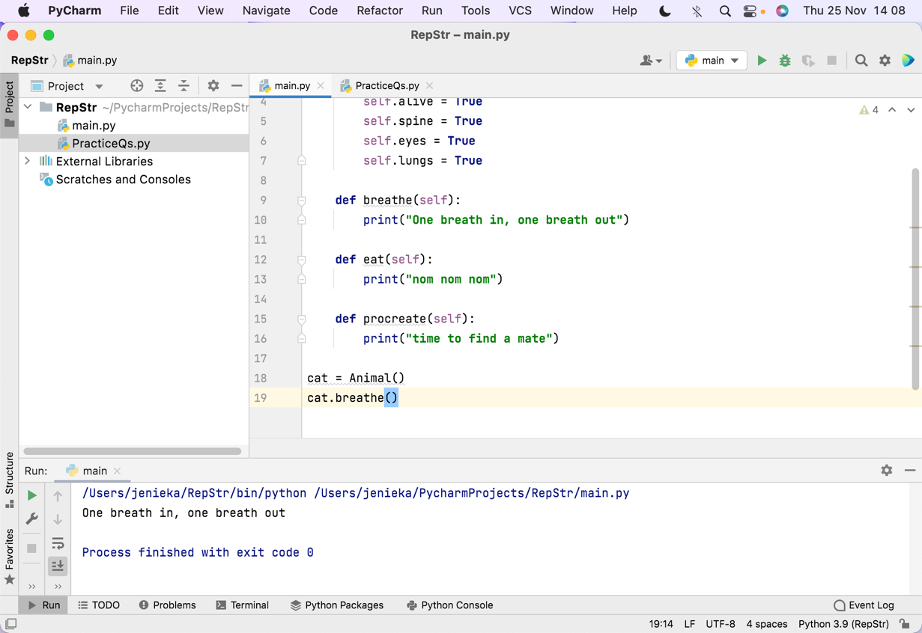 … and how to use it.

A different example but you cant see the whole class (the start has been cut off).

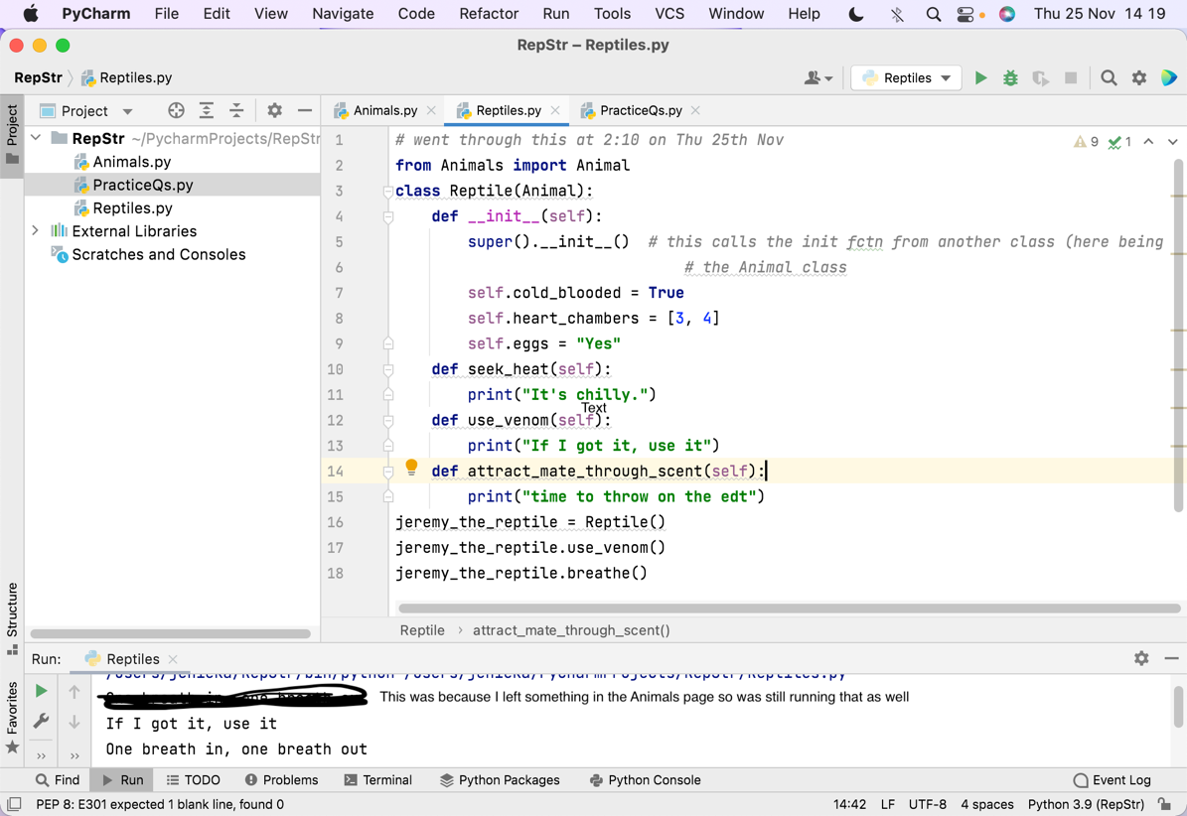

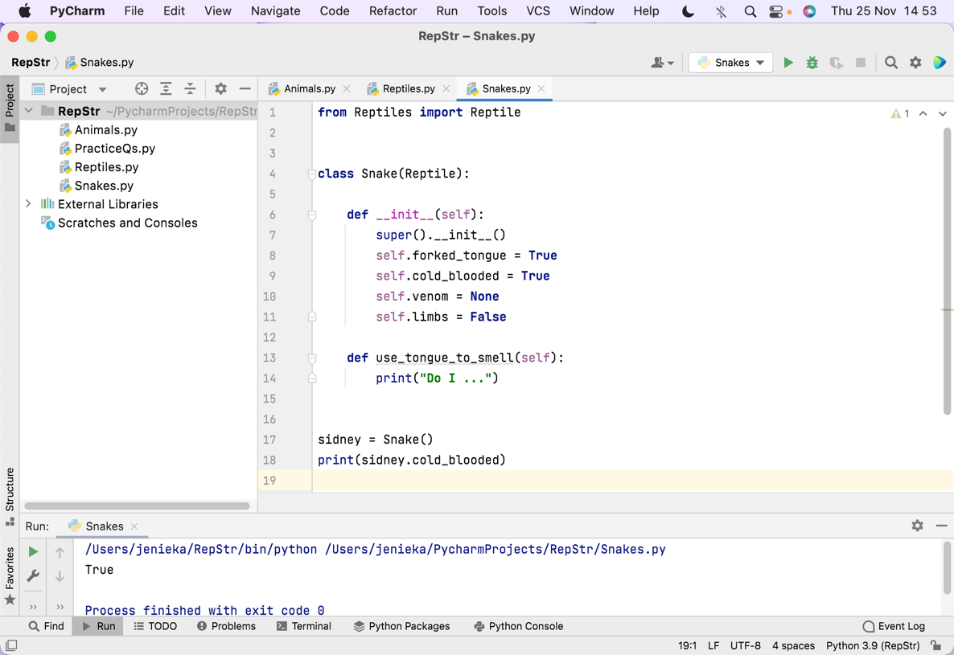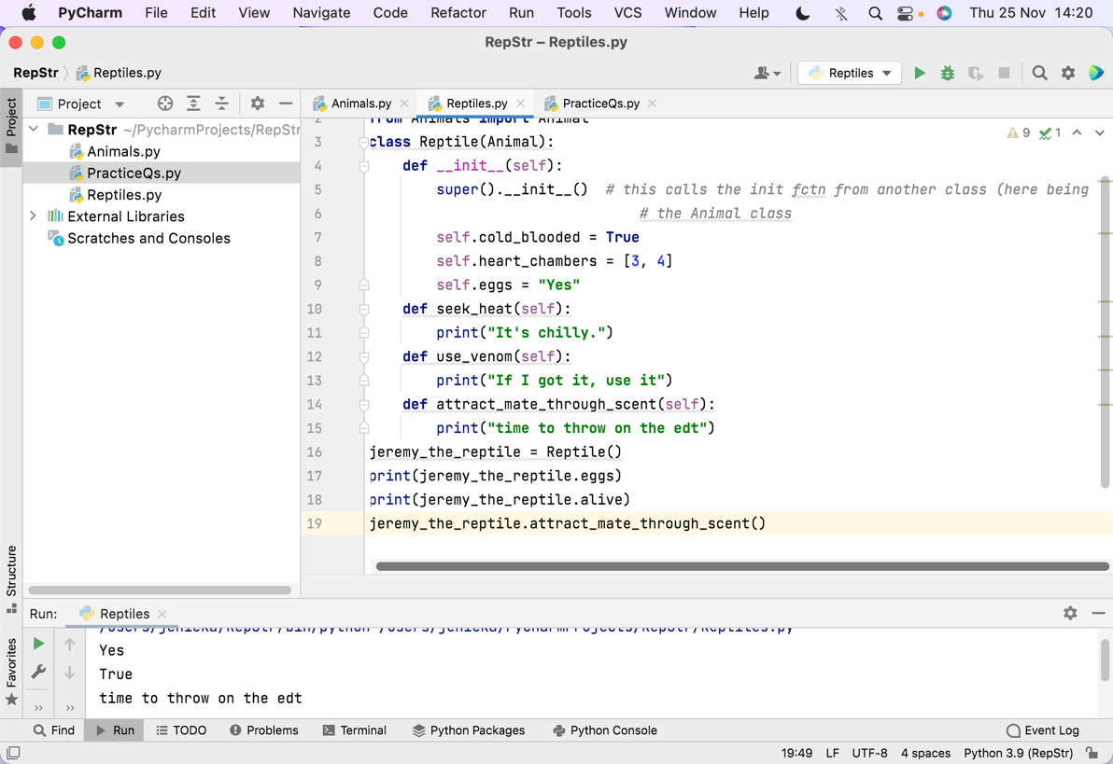 New example. Following ss’s just show how to use the classes and keep adding classes.

